Supplement 1: List of species and location of populations included in analyses

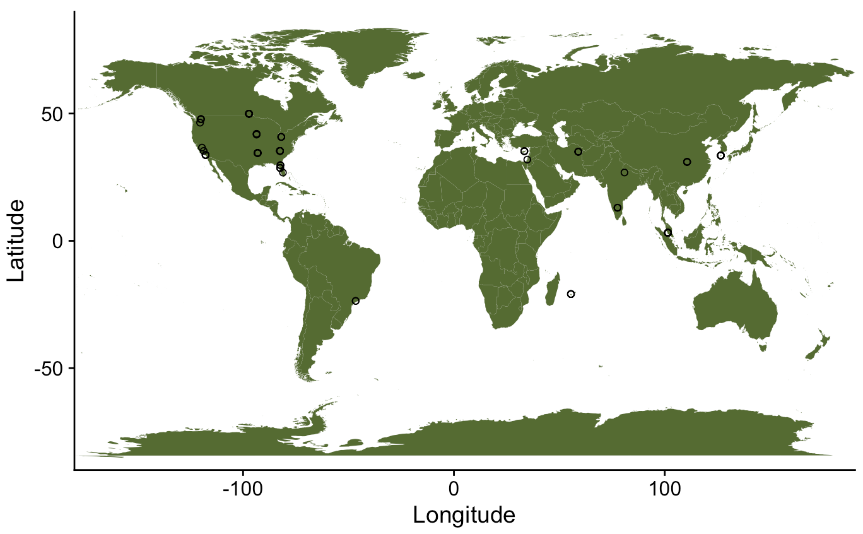

Figure S1. Location of study populations in the analytical data set. Figure generated using the R package “maps”¹.

Table S1. List of 26 species constituting the analytical data set.
Species | family
Herpetogramma phaeopteralis | Crambidae
Chilo sacchariphagus | Crambidae
Keiferia lycopersicella | Gelechiidae
Ascotis selenaria | Geometridae
Marmara gulosa | Gracillariidae
Spalgis epius | Lycaenidae
Mamestra configurata | Noctuidae
Peridroma saucia | Noctuidae
Chilo auricilius | Noctuidae
Lacanobia subjuncta | Noctuidae
Spodoptera exigua | Noctuidae
Cerconota anonella | Oecophoridae
Ectomyelois ceratoniae | Phycitidae
Ephestia figulilella | Phycitidae
Homadaula anisocentra | Plutellidae
Metisa plana | Psychidae
Pteroma pendula | Psychidae
Elasmopalpus lignosellus | Pyralidae
Ameyelois transitella | Pyralidae
Orthopygia glaucinalis | Pyralidae
Lista haraldusalis | Pyralidae
Rhyacionia frustrana | Tortricidae
Ancylis comptana | Tortricidae
Episimus utilis | Tortricidae
Argyrotaenia velutinana | Tortricidae
Cydia pomonella | Tortricidae

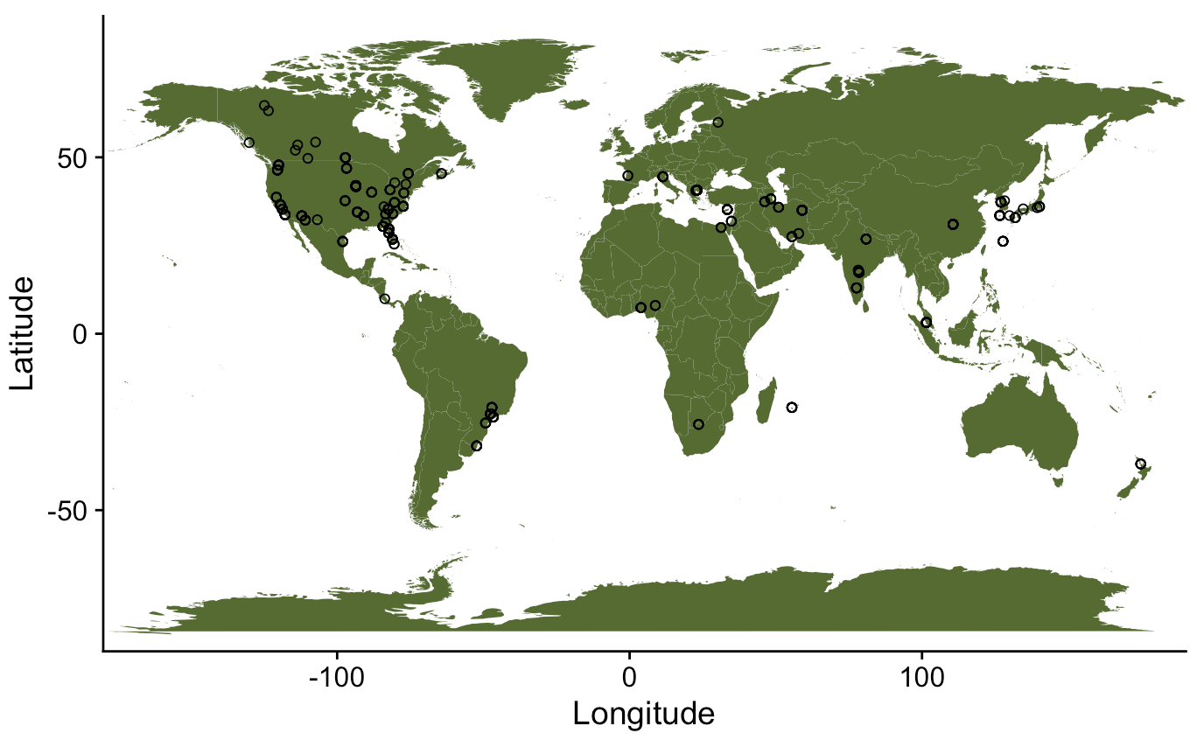

Figure S2. Location of study populations included in the full data set (analysis of this data set is reported in supplement 2). Figure generated using the R package “maps”¹.

Table S2. List of 89 species constituting the full data set.

Species | Family
Utethesia ornatrix | Arctiidae
Bedellia somnulentella | Bellelliidae
Carposina sasakii | Carposinidae
Cochylis hospes | Cochylidae
Herpetogramma phaeopteralis | Crambidae
Chilo sacchariphagus | Crambidae
Pediasia trisecta | Crambidae
Diaphania nitidalis | Crambidae
Diaphania indica | Crambidae
Ostrinia nubilalis | Crambidae
Diatraea grandiosella | Crambidae
Palpita nigropunctalis | Crambidae
Neoleucinodes elegantalis | Crambidae
Cnaphalocrocis medinalis | Crambidae
Stenoma catenifer | Elachistidae
Lymantria albescens | Erebidae
Lymantria xylina | Erebidae
Keiferia lycopersicella | Gelechiidae
Anarsia lineatella | Gelechiidae
Tuta absoluta | Gelechiidae
Pectinophora gossypiella | Gelechiidae
Aproaerema modicella | Gelechiidae
Phthorimaea operculella | Gelechiidae
Ascotis selenaria | Geometridae
Marmara gulosa | Gracillariidae
Phyllonorycter blancardella | Gracillariidae
Spalgis epius | Lycaenidae
Lycaeides argyrognomom | Lycaenidae
Mamestra configurata | Noctuidae
Peridroma saucia | Noctuidae
Argyrogramma albostriata | Noctuidae
Chilo auricilius | Noctuidae
Sesamia nonagrioides | Noctuidae
Spodoptera cosmioides | Noctuidae
Lacanobia subjuncta | Noctuidae
Spodoptera exigua | Noctuidae
Panolis flammea | Noctuidae
Heliothis subflexa | Noctuidae
Heliothis virescens | Noctuidae
Heliothis zea | Noctuidae
Hypantria cunea | Noctuidae
Leucania separata | Noctuidae
Pseudaletia unipuncta | Noctuidae
Simyra henrici | Noctuidae
Trichoplusia ni | Noctuidae
Egira curialis | Noctuidae
Spodoptera litura | Noctuidae
Naranga aenescens | Noctuidae
Sesamia cretica | Noctuidae
Anticarsia gemmatalis | Noctuidae
Inachis io | Nymphalidae
Danaus plexippus | Nymphalidae
Cerconota anonella | Oecophoridae
Atrophaneura alcinous | Papilionidae
Sericinus montela | Papilionidae
Ectomyelois ceratoniae | Phycitidae
Ephestia calidella | Phycitidae
Ephestia figulilella | Phycitidae
Homadaula anisocentra | Plutellidae
Plutella xylostella | Plutellidae
Metisa plana | Psychidae
Pteroma pendula | Psychidae
Diatraea saccharalis | Pyralidae
Dioryctria amatella | Pyralidae
Ameyelois transitella | Pyralidae
Cactoblastis cactorum | Pyralidae
Maruca vitrata | Pyralidae
Euzopherodes vapidella | Pyralidae
Elasmopalpus lignosellus | Pyralidae
Orthopygia glaucinalis | Pyralidae
Hypocosmia pyrochroma | Pyralidae
Lista haraldusalis | Pyralidae
Cadra cautella | Pyralidae
Corcyra cephalonica | Pyralidae
Plodia interpunctella | Pyralidae
Diatraea lineolata | Pyralidae
Hypsipyla grandella | Pyralidae
Attacus ricini | Saturnidae
Platynota idaeusalis | Tortricidae
Rhyacionia frustrana | Tortricidae
Ancylis comptana | Tortricidae
Cydia pomonella | Tortricidae
Episimus utilis | Tortricidae
Ctenopseustis obliquana | Tortricidae
Adoxophyes orana | Tortricidae
Choristoneura fumiferana | Tortricidae
Argyrotaenia velutinana | Tortricidae
Croesia curvalana | Tortricidae
Lobesia botrana | Tortricidae

References

- Becker OScbRA, Minka ARWRvbRBEbTP, Deckmyn. A (2022). _maps: Draw Geographical Maps_. R package version 3.4.1, <https://CRAN.R-project.org/package=maps>.

